International Forecourt

S t a n d a r d s F o r u m
Current address and Telephone / Fax numbers are available from IFSF
website www.ifsf.org

E-mail: secretary@ifsf.org techsupport@ifsf.org

IFSF ENGINEERING BULLETIN NO. xx IFSF REMC REST Services – Implementation Guidelines

1. INTRODUCTION

1.1 Background
This is an International Forecourt Standards Forum (IFSF) Engineering Bulletin. Its purpose is to help IFSF Technical Interested Parties (TIPs) to develop and implement IFSF standards.
An Engineering Bulletin collects all the available technical information about a single subject into one document to assist development and implementation of the IFSF communication specification over LONWORKS and TCP/IP protocols in the service station environment. The information is provided by TIPs, third party organisations such as CECOD, Conexxus, LonMark and NRF, and the IFSF member oil companies,
Any comments or contribution to this or any other Engineering Bulletin is welcome. Please e-mail any comments or contributions to techsupport@ifsf.org. The IFSF is particularly anxious that any known errors or omissions are reported promptly so that the document can be updated and reissued and remain a useful and working practical publication.

1.2 Scope
This document specifies general principles in implementing IFSF devices within the IXRetail REMC standard. It stems from work done in 2002-2005 when IFSF and ARTS met to include the IFSF forecourt model into the ARTS data model. The IFSF data model includes equipment and event data. This EB is based on EB19 and provides an update to implement the REMC standard on REST services and to enhance funtionalities.

1.3 Definitions
API Application Programming Interface. An API is a set of routines, protocols, and tools for building software applications
BOS Back Office Server
CD (IFSF) Controller Device
CHP Central Host Platform (the host component of the web services solution)
EB Engineering Bulletin
FP (IFSF) Fuelling Point (in customer terminology the common name is “pump”)
IFSF International Forecourt Standards Forum
JSON JavaScript Object Notation; is an open standard format that uses human-readable text to transmit data objects consisting of attribute-value pairs
REMC Remote Equipment Monitoring and Control
REST REST (REpresentational State Transfer) is an architectural style, and an approach to communications that is often used in the development of Web Services.
TIP IFSF Technical Interested Party
URI Universal Resource Identifier. In computing, a URI is a string of characters used to identify a name of a resource
URL Universal Resource Locator. The most common form of URI is the uniform resource locator (URL), frequently referred to informally as a web address.
XML Extensible Markup Language is a markup language that defines a set of rules for encoding documents in a format which is both human-readable and machine-readable
ARTS Association for Retail Technical Standards
BMS Building Management System (or software)
CES Central Equipment Server (in the context of RESTful Services this is equivalent to the CHP)
FMC Facilities Management Contractor
HVAC Heating, Ventilation and Air Conditioning
IFSF Standard A document containing specifications for the inter-connectivity of a forecourt device and controller device.
IRMA Integrated Retail Maintenance Activities
MTBF Mean Time Between Failures (as defined in ISO2382-14).
RED Remote Equipment Diagnostics
SES Site Equipment Server (in the context of RESTful services this is equivalent to the Site System)
WAN Wide Area Network
XSD XML Scheme Definition
SMTP Simple Mail Transfer Protocol

Other terms used within this report are defined in appropriate ISO, IFSF or ARTS documentation. Any definition of terms required for clarification or interpretation purposes should be addressed to the document author.
The key ISO standard for maintenance activity definitions is section 14 of Information Technology - Vocabulary - Reliability, maintainability and availability [Ref. ISO2382].

1.4 Acknowledgements
The IFSF gratefully acknowledge the contribution of the following people in the preparation of this publication:

Name | Organisation
John Carrier | IFSF Projects Manager (Reviewer)
Gonzalo Fernandez Gomez | OrionTech (Editor)
Axel Mammes | OrionTech (Reviewer)

2. Maintenance Management
The primary purpose of this EB is to define how to implement IFSF equipment (devices) within the REMC standard. It defines at a high level the data model; Data definitions (format, content and data coding conventions) and interface file definitions. This document is based on previous engineering Bulletin EB19 (EB19_IFSF IXRetail REMC devices - Implementation Guidelines V0 01.doc), extending its functionality to also capture data points and to be highly extensible for new device types in accordance to the IOT (internet Of Things) trend.

2.1 Protocol requirements
- The communication protocol must be based on REST/JSON messages.
- It must be possible for the site to publish information for multiple devices but it must also be possible for a device to publish its own data to a central host (Internet of Things)
- A site may publish one or multiple data entities in a single message.
- The data entities and the URLs must be generic and must not make any assumption about which equipment type provides the information. The current focus is on ATG and Dispenser monitoring but this may be extended for other equipment types (car wash, price pole, receipt printer, fridge, etc.)
- The protocol should not define which events and or data points are captured.
- The definition of the data points should be generic; just data points having values, no references to specific equipment.
- Standardization of the data points names for interoperability.
- Each measurement / data point can have multiple values. Each value has a datetime included.
- Indefinite levels of equipment / sub-equipment description and data points must be achieved.

Notes on the protocol requirements
Although the protocol will define generic data points, the naming convention for both a device and a data point must be consistent for all devices of the same type.
To achieve this, the data points ID will be a unique identifier for the corresponding IFSF application database Name and record ID for the corresponding device.

3. SITE EQUIPMENT MAINTENANCE ARCHITECTURE

3.1 Systems Architecture
The figure below shows the IFSF architecture for remote equipment maintenance. It is not within the scope of this project to define the architecture, software, hardware or infrastructure of the Facilities Management Contractor (FMC) system. The host end of the remote equipment diagnostics application is called the REMC Central Processing Host (CHP) and is in charge of resending the information to the FMC. The application at the site is called the REMC Agent Device. One or several RAS can be implemented at the site.

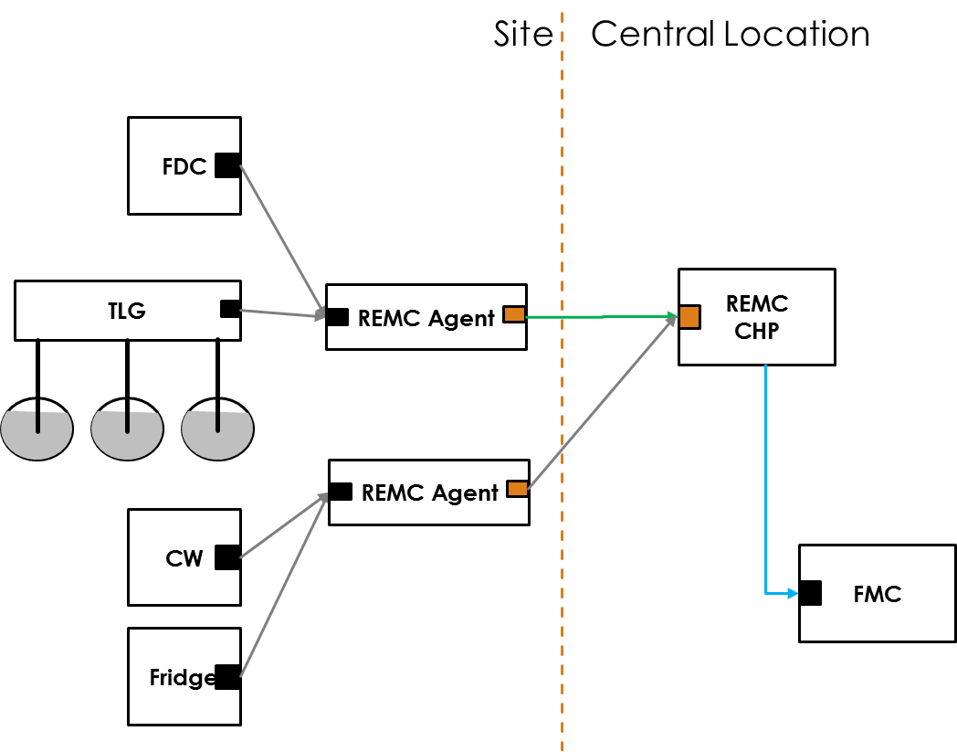

Figure 3.1: Example of IFSF Equipment Architecture

3.2 Implementation scenarios
REMC can be used either by configuring REMC agents to push records to the CHP or by configuring a CHP to poll the agent for new records. See API resources and verbs for more information on available entry points to implement each scenario.

3.2.1 Use Cases
Agent first time install:
The agent will have a list of devices. Devices may be automatically discovered or manually configured by technician.
When connecting to CHP, site will request the devices configured at CHP to update server. If no devices at CHP, Agent will post all discovered devices. and its corresponding points.
Agent is reinstalled:
The agent will generate again the list of devices. Devices may be automatically discovered or manually configured by technician. the agent must ensure that the unique device ID for each site device is generated with the same value for each device.
When connecting to CHP, site will request the devices configured at CHP to update server. As devices are already present at CHP, Agent will post any new discovered device, if applicable, as well as any new points collected.
CHP is reinstalled
If CHP is reinstalled, if the database is lost, the agent will detect that no device is configured in the site list, and will upload each device to the CHP and will move all devices configuration parameters to the agent points list to be queued to update CHP.
If CHP polls for REMC records, it will request all records and update the device configuration accordingly.
If Agent pushes points to CHP, as all device configuration data is moved to the points queue, agent will update the CHP with all site devices configuration.
New device detected:
The agent will collect device configuration and will copy the information as new items in the agent points list to be queued to update CHP.
Device configuration change.
If a device configuration change is detected, all new configuration parameters will be moved to the agent points list to be queued to update CHP.
Device configuration expires:
When a configuration expired is received from the CHP for a specific device, the most recent configuration will be copied as new items in the agent points list to be queued to update CHP.
No communication with CHP:
If there is no communication with CHP (e.g. network down, configuration error, API key mismatch, etc.), the agent will queue any new points until CHP communication is restored.
Two agents at the same site updating information:
Out of scope of this analysis, but agents must make sure not to duplicate information at CHP.
Device configuration data is modified above site:
Current scenario server does not push configuration to the sites. If configuration was modified at CHP, agent will detect a different configuration timestamp and will queue configuration information to update CHP configuration.
Device is offline:
After a defined timeout period, the agent will queue an alarm indicating that the device is offline.
Device is removed/replaced:
The application shall define a way not to queue an offline alarm. In the case the device is removed, a delete command must be pushed to CHP. CHP shall delete or disable the device according to its business rules. the way to communicate a replaced equipment will be up to the implementing app, adding a new device or updating the currently defined as per the agent business rules.

4. DATA DEFINITIONS

The terms and identifiers used in this specification are defined as follows.

4.1 General

4.1.1 Time Stamps
A series of ISO 8601 (UTC) date time fields that indicates the exact date and time, at which the equipment or alert message was first detected, created, amended, deleted, refreshed, sent or acknowledged.

4.1.2 ASCII Text Character Set
Since this interface must interconnect with forecourt devices the character set used for ASCII text must comply with the minimum defined by the IFSF for forecourt devices. This is defined in IFSF Engineering Bulletin No 5, Character and Number Representation [Ref. IFSF E5].

4.1.3 Numeric amounts in character strings
This is defined in IFSF Engineering Bulletin [Ref. IFSF E5], which is itself derived from an ISO standards ISO 6093 - 1985 (E), Information processing - Representation of numerical values in character strings for information interchange see [Ref. ISO 6093].

4.2 Identifiers and Coding Systems

4.2.1 REMC Record Identifier

The record identifier is used to uniquely identify data points collected by the agent. The record identifier consists of two parts: {recordBlock}:{sequenceNumber} record block is a unique identifier that is the a datetime value calculated every time the sequenceNumber is reset to 1 in the format yyyymmddhhmmss. Reasons of resets are sequence number rollover and REMC agent reinstallations. If a REMC CHP requests data from the site REMC agent for the first time, it shall request all events available. It will then store the last record block and sequence number pair. Future event requests shall include a filter lastReadEvent with the last record block and event number received. REMC agent shall return all events generated later than the value in the lastReadEvent parameter. If the required record block is not defined in the agent, the agent shall respond with all stored records. This will cover agent reinstallation and full event queue rollover scenarios.

4.2.1 EquipmentID and EquipmentName
Naming Devices: Any device will be uniquely identified by two elements:
- deviceType
- deviceID
deviceType determines what type of device is referred and to what application standard describes the device.
Some valid device types include:
- IFSF.PUMP
- IFSF.PUMP.DSP
- IFSF.PUMP.DSP.NOZZLE
- IFSF.TLG
- IFSF.TLG.TP
- IFSF.PRICE
- IFSF.PRICE.PP
- IFSF.WASH
IFSF recognizes that there are several device types that can be monitored over SNMP. SNMP provides a standard way of exchanging configuration information, device values and alarms. In this case, the agent will receive the SNMP information and traps and will register the device as an SNMP device. SNMP devices will have a generic device type:
SNMP.{DeviceTypeDescriptor}
Where SNMP will indicate that the device is polled over SNMP and the device type descriptor will be a unique type for the corresponding device type. the last item in the type will uniquely define the corresponding MIB tree structure where the information is stored in the device.
Examples:
- SNMP.ROUTER.CISCO
- SNMP.UPS.ATEN
- SNMP.ENERGYMON.EINSTEIN
- SNMP.PC.WIN

The last example can be used to monitor the status of workstations at site. Windows Operating system provides and SNMP agent capable of monitoring workstation parameters such as CPU usage, Memory, Disk space, etc.
Once device type is determined, the device ID will be defined by using a unique ID that must be retrievable after agent reinstallation.One alternative we propose to determine the equipment ID is to use the IFSF LON device identification.
Examples of possible device ID naming for site 12345678.
For a Car Wash (from EB19 document):
device/class: "IFSF.WASH"
device/ID: "IFSF.WASH:12345678:WASH:1"
For a pump Nozzle (Nozzle 1 of Fueling position 2 of dispenser 3):
device/class: "IFSF.DSP.FP.NOZZLE"
device/ID: "IFSF.DSP.FP.NOZZLE:12345678:03:02.1"
For an SNMP Device:
device/class: "SNMP.UPS.APC"
device/ID: "SNMP.UPS.APC:12345678:172.023.014.005"

4.2.2 Naming Configuration and Data Points
For IFSF devices:
For each IFSF device, there is an application that describes the information that can be retrieved from the device, the database name and record that holds each piece of information.
Each point will be uniquely identified with the Database Name and record ID for the requested point. Optionally, a record friendly name can be added for better readability.
Examples (extracted from part 3.01):

device/class: "IFSF.DSP.FP.NOZZLE"
device/ID: "IFSF.DSP.FP.NOZZLE:12345678:03:02.1"
config/code: "DBLND:01H"
config/name "Dispensed Product ID"

config/code: "DBLND:08H"
config/name: "Meter_1_Blend_Ratio"

config/code: "DBLND:14H"
config/name: "Log_Noz_Vol_Total"

For SNMP devices:
Each SNMP device has a tree structure that stores the device information. Each element of the tree can be retrieved by a unique identifier called OID.
The OID for each element will be used to identify the corresponding data point.
Examples:
device/class: "SNMP.UPS.APC"
device/ID: "IFSF.UPS.APC:12345678:172.023.014.005"
config/code: "IFSF.UPS.APC:0.1.34.15"
config/name: "Battery Voltage"

4.2.3 Naming Alarms
TBD. Need to discuss with John if there is any standard naming convention for events at each application specification.

5. API DEFINITION

The following information provides and overview of the APIs defined. Two APIs were defined:

- REMC AGENT API: Defines the set of entities and verbs exposed at the site REMC agent, enabling a CHP to connect to the site and collect information.
- REMC CHP API: Defines the set of entities and verbs exposed at the CHP REMC server for the site agent to be capable of pushing information to the server.

5.1 REMC AGENT API

5.1.1 Exposed Resources and verbs:

/sites:
get:
displayName: List of site IDs monitored by this agent
description: This collection usually only has one item because an agent usually only monitors a single site. However, it is technically possible for a single REMC agent instance to monitor two "sites". For example, this could happen at a single location with two forecourts, one for petrol/diesel and the other for Natural Compressed Gas, using two separate site identifiers.

/sites:/{siteID}:
get:
displayName: Allows REMC CHP to verify site details
description: General site information such as site id, address, etc.
The server will respond 200 if the site exists and API key can access the site, 404 if the site does not exist and 403 if the apikey cannot retrieve information for the requested site.

/sites:/{siteID}:/devices:
displayName: Devices description and configuration information
description: The device resource is used to store equipment information and configuration.
get:
displayName: Obtain a list of devices for a site
description: Will return a list of active devices at the site. Can be filtered by device type. This list contains a unique device identifier for each device and the last configuration change date time for each device, to notify the server that these devices need configuration update.

/sites:/{siteID}:/REMCRecords:
get:
displayName: Extract REMC records from the agent queue
description: Allows the CHP to query for REMC records available in the Device REMC RecordsQueue. The lastPointReceivedFilter will instruct the agent to return only remcRecords queued after the referenced record. If recordBlock is set to 0, then all events in the queue will be returned. This allows for multiple REMC CHPs to query agents.

/subscriptions:
description: >
Out of scope of current release. Allows a CHP to request an Agent to be notified of events automatically. For discussion at meeting.
get: Allows a central server to get the list of enabled subscriptions.
put: Allows the CHP to update a subscription record with its information for posting events.
Subscription information:
[ServerName, URI, enabled, oauthServerURI, bearerToken, bearerTokenExpiration]
Need to understand how the subscription will be managed and bearer tokens updated.
If not used, the technician will configure the subscription information and
apikey at the agent.

5.2 REMC CHP API

5.2.1 Exposed Resources and verbs:

/sites:
get:
displayName: Returns site listing
description: Returns the list of siteIDs available for the agent. As each agent apikey will normally enable access to a single site, the result usually willcontain a single item.
This information will enable the REMC Agent to verify that it has access to post information for a certain site.

/sites:/{siteID}:
get:
displayName: Returns basic site information.
description: General site information such as site id, address, etc.
The server will respond 200 if the site exists and API key can access the site, 404 if the site does not exist and 403 if the apikey cannot retrieve information for the requested site.

/sites:/{siteID}:/devices:
displayName: Device description and optional configuration information
description: The device resource is used to store equipment information and configuration. To update its configuration information, the agent will post new events records to a CHP processing queue.
get:
displayName: Obtain a list of devices for a site
description: The get command will return a list of all device nodes defined for a site including its configuration datetime. The datetime will be used by the site application to verify if configuration has changed for any device and update the CHP accordingly. An Expired parameter will indicate the client that the configuration needs to be refreshed. In any case, any device configuration update will be submitted through REMCRecords. The view query parameter enables the agent to query the CHP for the complete device configuration information (using view=verbose). This comes useful after an agent reintallation to populate the agent configuration database.
Usage: <BaseURI>/sites/{siteID}/devices/?view=verbose

delete:
displayName: Delete devices from the CHP.
description: Used for the agent to notify the REMC CHP that a device was removed from the site. CHP should reject any further REMC records for that device. Delete verbs will enable the site agent to send a list of devices to be removed/disabled from the central database.

/sites:/{siteID}:/REMCRecords:
post:
displayName: Used by the REMC agents to push REMC records to host.
description: The agent will push REMC records to CHP. Agent must make sure to only post new records to CHP. If agent send duplicated records, CHP will reject due to duplicate record ID. When config events are posted to CHP, the CHP will update the configuration data if necessary and update the device config expiration date.

/results:/{referenceID}:
get:
displayName: Returns a list of processing results by reference
description: The agent can use this resource to retrieve the results of the asynchronous REMC records POST.

